 



Database Programming with SQL 3-2: Sorting Rows

Practice Activities

# Objectives

* Construct a query to sort a result set in ascending or descending order
* State the order in which expressions are evaluated and calculated based on the rules of precedence
* Construct a query to order a result set using a column alias
* Construct a query to order a result set for single or multiple columns

# Vocabulary

Identify the vocabulary word for each definition below.

|  |  |
| --- | --- |
| **ASC** [Ascending] | Orders the rows in ascending order (the default order); A-Z |
| **DESC**  [ Descending] | Orders the rows in descending order: Z-A |
| **Sorting** | To arrange according to class, kind, or size |

# Try It / Solve It

1. In the example below, assign the employee_id column the alias of “Number.” Complete the SQL statement to order the result set by the column alias.

SELECT employee_id, first_name, last_name FROM employees;

SELECT employee_id as "Number", first_name, last_name

FROM employees

ORDER BY "Number";

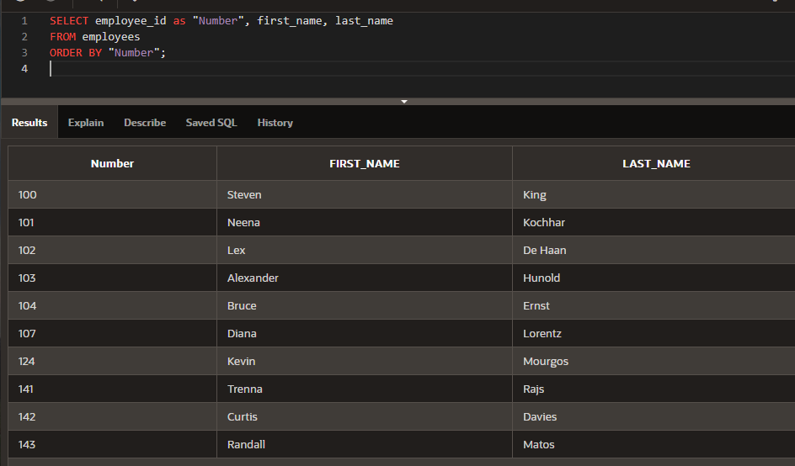

1. Create a query that will return all the DJs on Demand CD titles ordered by year with titles in alphabetical order by year.

SELECT title

FROM d_cds

ORDER BY year, title;

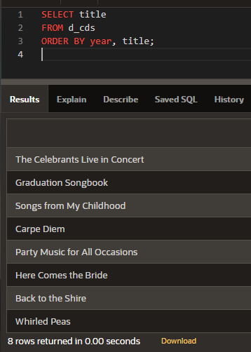

1. Order the DJs on Demand songs by descending title. Use the alias “Our Collection” for the song title.

SELECT title as "Our Collection"

FROM d_cds

ORDER BY  title DESC;

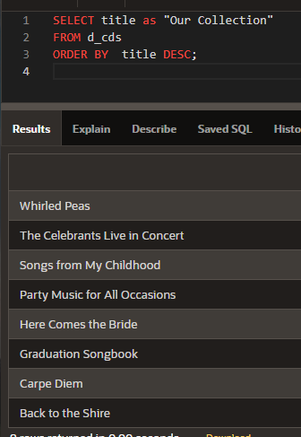

1. Write a SQL statement using the ORDER BY clause that could retrieve the information needed. Do not run the query.

Create a list of students who are in their first year of school. Include the first name, last name, student ID number, and parking place number. Sort the results alphabetically by student last name and then by first name. If more than one student has the same last name, sort each first name in Z to A order. All other results should be in alphabetical order (A to Z).

SELECT first_name,  last_name,  student_id ,  parking_number

FROM students

WHERE year = 1

ORDER BY  last_name ,  first_name DESC;

1. Write a SQL statement using the employees table and the ORDER BY clause that could retrieve the information in the following table. Return only those employees with employee_id<125.

|  |  |  |
| --- | --- | --- |
| **DEPARTMENT_ID** | **LAST_NAME** | **MANAGER_ID** |
| **90** | **Kochhar** | **100** |
| **90** | **King** | **(null)** |
| **90** | **De Haan** | **100** |
| **60** | **Lorentz** | **103** |
| **60** | **Hunold** | **102** |
| **60** | **Ernst** | **103** |
| **50** | **Mourgos** | **100** |

SELECT department_id , last_name, manager_id

FROM employees

WHERE employee_id<125

ORDER BY  department_id DESC , last_name DESC;

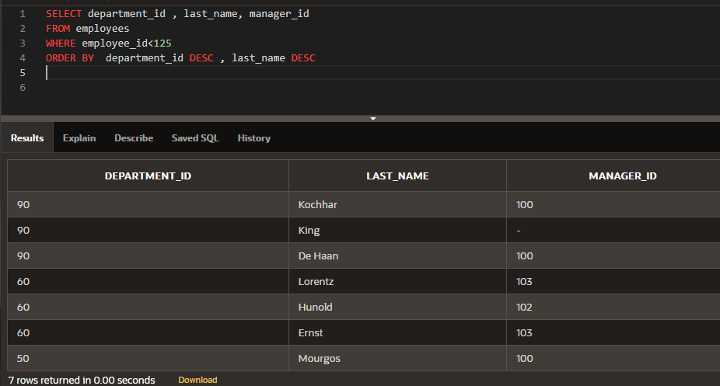

***Extension Activities***

1. Limiting values with the WHERE clause is an example of:
   1. Projection
   2. Ordering
   3. Joining
   4. Grouping
   5. Selection
2. You want to sort your CD collection by title, and then by artist. This can be accomplished using:
   1. WHERE
   2. SELECT
   3. ORDER BY
   4. DISTINCT
3. Which of the following are SQL keywords?
   1. SELECT
   2. ALIAS
   3. COLUMN
   4. FROM
4. Which of the following are true?
   1. Multiplication and division take priority over addition.
   2. Operators of the same priority are evaluated from left to right.
   3. Parentheses can be used to override the rules of precedence.
   4. None of the above are true.
5. The following query was written: SELECT DISTINCT last_name FROM students
   1. To select all the outstanding students
   2. To choose last names that are duplicates
   3. To select last names without duplicates
   4. To select all last names
6. The following string was created using which SELECT clause?

Abby Rogers is an order taker for Global Fast Foods

* 1. SELECT first_name ||' ' ||last_name ||' is an ' staff_type ' for Global Fast Foods'
  2. SELECT Abby Rogers is an ||staff_type||' for Global Fast Foods'
  3. SELECT first_name,last_name '||staff_type||' for Global Fast Foods'
  4. SELECT first_name ||' ' ||last_name ||' is an '||staff_type||' for Global Fast Foods'

1. Which of the following SELECT clauses will return uppercase column headings?
   1. SELECT id, last_name, address, city, state, zip, phone_number;
   2. SELECT ID, LAST_NAME, ADDRESS, CITY, STATE, ZIP, PHONE_NUMBER;
   3. SELECT Id, Last_name, Address, City, State, Zip, Phone_number;
   4. SELECT id AS ID, last_name AS NAME, address AS ADDRESS, city AS CITY, state AS STATE, zip AS ZIP, phone_number AS PHONE_NUMBER;
2. Which SELECT statement will **always** return the last names in alphabetical order?
   1. SELECT last_name AS ORDER BY FROM employees
   2. SELECT last_name FROM employees ORDER BY last_name
   3. SELECT last_name FROM employees
   4. SELECT ASC last_name FROM employees
3. Which SELECT clause will return a column heading for employee_id called “New Employees”?
   1. SELECT last_name AS "New Employees"
   2. SELECT employee_id AS New Employees
   3. SELECT employee AS "New Employees"
   4. SELECT employee_id AS "New Employees"
4. Examine the following query: SELECT last_name, job_id, salary FROM employees

WHERE job_id = 'SA_REP' OR job_id = 'AD_PRES' AND salary >15000; Which results could not have been returned from this query?

* 1. Joe Everyone, sales representative, salary 15000
  2. Jane Hendricks, sales manager, salary 15500
  3. Arnie Smithers, administration president, 20000
  4. Jordan Lim, sales representative, salary 14000

1. Finish this query so it returns all employees whose last names start with “St”. SELECT last_name

FROM employees

WHERE last_name LIKE 'St%';

1. What salary values will not be returned from this query? SELECT last_name, first_name, salary

FROM employees

WHERE salary BETWEEN 1900 AND 2100;

Которые больше 2100 и меньше 1900

1. Correct each WHERE clause:
   1. WHERE department_id NOT IN (101,102,103);
   2. WHERE last_name = ‘King’
   3. WHERE start_date = "05-May-1998"
   4. WHERE salary BETWEEN 5000 AND 7000
   5. WHERE id != 10
2. SELECT prefix FROM phone

WHERE prefix BETWEEN 360 AND 425 OR prefix IN (206,253,625)

AND prefix BETWEEN 315 AND 620;

Which of the following values could be returned? 625, 902, 410, 499